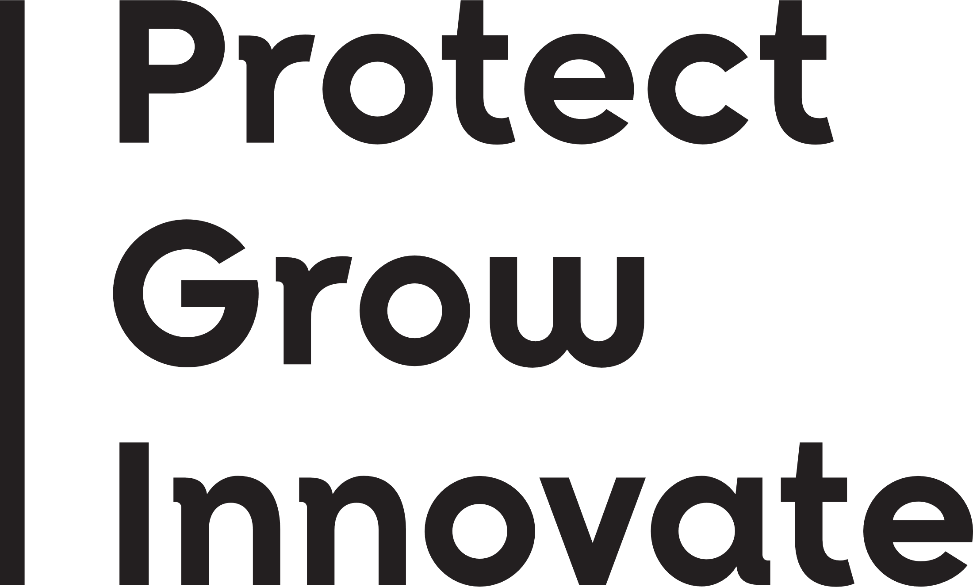



## Project Completion Report

## Wildlife Animal Ethics Committee (WAEC)

|  |  |
| --- | --- |
| 1. **Current WAEC approval number:** | **WAEC XX-XX-XX** |
| 1. **Project title:** |  |
| 1. **Project duration:** | Date from **–** Date to |
| 1. **Chief Investigator (CI):** |  |
| 1. **Project outcomes:** | |
| **Please list the aims of the project and provide a summary of the outcomes for each of the aims over the life of the project.**  *Information provided in this section should assist the Committee in assessing how well the project delivered against the aims and objectives and provide a summary of what has been learnt during the project. Under the Code, a project must demonstrate its value to ensure the potential effects on the wellbeing of animals is justified.*  *It should include information on how the data collected has or will contribute to your understanding of the species, systems or impacts you are investigating.* | |
| **Aims:** | |
|  | |
| **Summary of Outcomes:** | |
|  | |
| **Please also list any other information or achievements for the project:** | |
|  | |
| 1. **For any future projects you undertake, are there any learnings obtained arising from the outcomes?** | |
|  | |
| 1. **List and attach publications/reports derived from this project:** | |
|  | |

**Please email completed form to** [**wildlifeaec@dpird.wa.gov.au**](mailto:wildlifeaec@dpird.wa.gov.au)